Understanding Various Types of WCF Bindings

WCF binding is a set of binding elements and each element specify, how the service and client will communicates with each other's. Each binding must have at least one transport element and one message encoding element.

Different Types of WCF Bindings

WCF has a couple of built in bindings which are designed to fulfill some specific need. You can also define your own custom binding in WCF to fulfill your need. All built in bindings are defined in the System.ServiceModel Namespace. Here is the list of 10 built in bindings in WCF which we commonly used:

1. Basic Binding

This binding is provided by the BasicHttpBinding class. It is designed to expose a WCF service as an ASMX web service, so that old clients (which are still using ASMX web service) can consume new service. By default, it uses Http protocol for transport and encodes the message in UTF - 8 text for-mat. You can also use Https with this binding.

1. Web Binding

This binding is provided by the WebHttpBinding class. It is designed to expose WCF services as Http requests by using HTTP-GET, HTTP-POST. It is used with REST based services which may give output as an XML or JSON format. This is very much used with social networks for implementing a syndication feed.

1. Web Service (WS) Binding

This binding is provided by the WSHttpBinding class. It is like as Basic binding and uses Http or Https protocols for transport. But this is designed to offer various WS - \* specifications such as WS – Reliable Messaging, WS - Transactions, WS - Security and so on which are not supported by Basic binding.

   wsHttpBinding= basicHttpBinding + WS-\* specification

1. WS Dual Binding

This binding is provided by the WsDualHttpBinding class. It is like as wsHttpBinding except it sup-ports bi-directional communication means both clients and services can send and receive messages.

1. TCP Binding

This binding is provided by the NetTcpBinding class. It uses TCP protocol for communication be-tween two machines with in intranet (means same network). It encodes the message in binary format. This is faster and more reliable binding as compared to the Http protocol bindings. It is only used when communication is WCF - to – WCF means both client and service should have WCF.

1. IPC Binding

This binding is provided by the NetNamedPipeBinding class. It uses named pipe for Communication between two services on the same machine. This is the most secure and fastest binding among all the bindings.

1. MSMQ Binding

This binding is provided by the NetMsmqBinding class. It uses MSMQ for transport and offers sup-port to disconnected message queued. It provides solutions for disconnected scenarios in which service processes the message at a different time than the client send the messages.

1. Federated WS Binding

This binding is provided by the WSFederationHttpBinding class. It is a specialized form of WS binding and provides support to federated security.

1. Peer Network Binding

This binding is provided by the NetPeerTcpBinding class. It uses TCP protocol but uses peer net-working as transport. In this networking each machine (node) acts as a client and a server to the other nodes. This is used in the file sharing systems like torrent.

1. MSMQ Integration Binding

This binding is provided by the MsmqIntegrationBinding class. This binding offers support to communicate with existing systems that communicate via MSMQ.

Choosing an Appropriate WCF Binding

Depending upon your requirements, you can choose a binding for your service as shown below in the diagram:

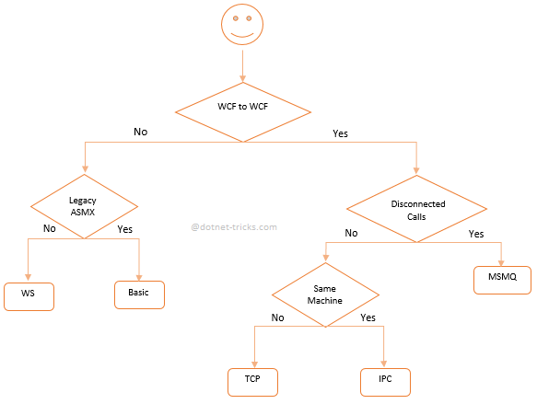

WCF Bindings Comparison

WCF Bindings Comparison

WCF Bindings Comparison

Binding Protocol/Transport Message Encoding Security Default Session Transaction Duplex

BasicHttpBinding Http, Https Text None No - -

WSHttpBinding Http, Https Text Message Optional Yes -

WSDualHttpBinding Http, Https Text Message Yes Yes Yes

NetTcpBinding TCP Binary Transport Optional Yes Yes

NetNamedPipeBinding Named Pipe Binary Transport Yes Yes Yes

NetMsmqBinding MSMQ Binary Transport Yes Yes No

WSFederationHttpBinding Http, Https Text Message Yes Yes No

NetPeerTcpBinding P2P Binary Transport - - Yes

MsmqIntegrationBinding MSMQ Not Supported Transport Yes Yes -